Modeling

📘 Definition
# Source: AI Source: Provided by: [Data Path: Persons Table -> ID Column: 1, Name_En Column: Motasem Essam] -> From: [ChatGPT] on [5/2/2026]
Modeling is the process of creating a 3D representation of an object using shapes, points, lines, and surfaces inside a computer.
It is the step where designers build the structure of objects before adding color, lighting, or animation.

🧊 How modeling works
# Source: AI Source: Provided by: [Data Path: Persons Table -> ID Column: 1, Name_En Column: Motasem Essam] -> From: [ChatGPT] on [5/2/2026]
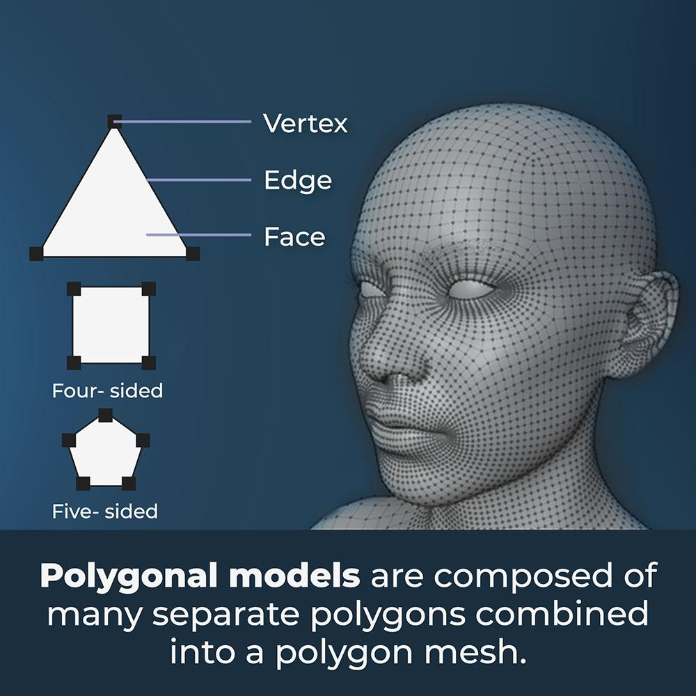
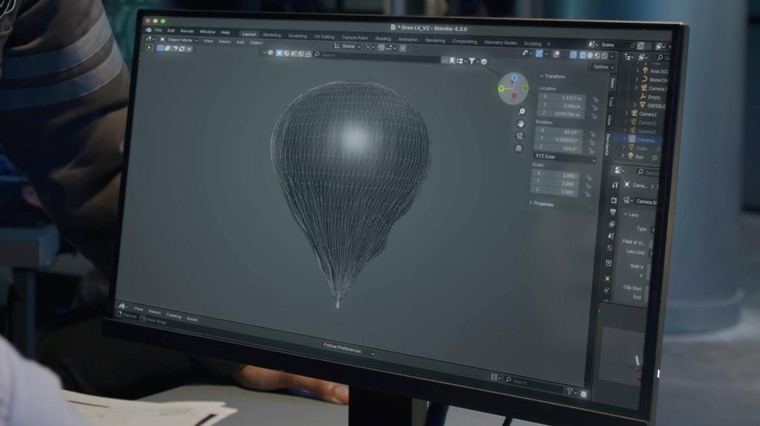

- Start with basic shapes (cube, sphere, cylinder)
- Break them into vertices (points)
- Connect them using edges and faces
- Shape them into a detailed 3D object

🧠 Simple example
# Source: AI Source: Provided by: [Data Path: Persons Table -> ID Column: 1, Name_En Column: Motasem Essam] -> From: [ChatGPT] on [5/2/2026]
Think of:
- 🧱 Building a house with Lego blocks
- 🎮 Creating a game character from basic shapes
- 🧊 Starting with a cube and turning it into a car or chair

🎮 Where modeling is used
# Source: AI Source: Provided by: [Data Path: Persons Table -> ID Column: 1, Name_En Column: Motasem Essam] -> From: [ChatGPT] on [5/2/2026]
- 🎮 Video game development
- 🎬 Movies and animation (CGI characters and scenes)
- 🏗️ Architecture design (buildings and interiors)
- 🧑‍🎨 Product and industrial design

⚙️ Key features
# Source: AI Source: Provided by: [Data Path: Persons Table -> ID Column: 1, Name_En Column: Motasem Essam] -> From: [ChatGPT] on [5/2/2026]
- 🧩 Builds the shape of 3D objects
- 📐 Uses vertices, edges, and faces
- 🎨 Happens before lighting and texturing
- 🏗️ Forms the foundation of 3D graphics

🚀 In short:
# Source: AI Source: Provided by: [Data Path: Persons Table -> ID Column: 1, Name_En Column: Motasem Essam] -> From: [ChatGPT] on [5/2/2026]
Modeling = creating the shape and structure of a 3D object inside a computer before adding details like color, texture, and lighting.

